**LATEST ADVANCEMENT IN THE FIELD OF AI**

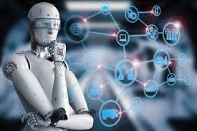

As the world becomes increasingly digital, the field of artificial intelligence (AI) continues to grow and evolve at an **unprecedented** pace. From chat-bots and virtual assistants to **self-driving** cars and **predictive analytics**, AI is transforming the way we live and work. The latest advertisements in the field of AI are all about showcasing the incredible capabilities and benefits of this **cutting-edge technology.** Companies are using AI to automate repetitive tasks ,streamline processes, and create more personalized experiences for their customers.

AI is being used to analyze patient data and improve diagnosis accuracy,it is being used to detect fraud and **automate trading**. In retail, AI-powered chat-bots are helping customers find the **products** they need and providing **personalized recommendations**. The latest AI advertisements are also emphasizing the importance of ethical and responsible use of the technology. Companies are highlighting their commitment to **transparency and privacy**, and showcasing how AI can be used to promote social good. AI, or Artificial Intelligence, is having a profound impact on numerous fields. From healthcare and finance to transportation and education, AI is transforming the way we live and work.

AI **algorithms** are being used to analyze large **datasets, identify patterns,** make predictions that help companies make better decisions. AI-powered chatbots are improving **customer service** by providing **24/7 support**, and machine learning models are optimizing supply chains and reducing waste.

Artificial Intelligence is an field of study that focuses on the development of intelligent machines that can learn, reason, and solve problems like humans. In recent years, AI has made significant advances in various areas, including computer vision, natural language processing, robotics, and machine learning. In this article, we will discuss some of the latest advancements in the field of AI.



* **GPT-3: The Language Model**
* **Computer Vision**
* **Machine Learning**
* **Robotics**
* **Lung Cancer Diagnosing**
* **AI in Education**
* **Generative Adversarial Networks**

**1.GPT-3:The Language Model**

GPT-3 (Generative Pre-trained Transformer 3) is an advanced language model that was released by OpenAI in June 2020. It is one of the most advanced AI models to date, with 175 billion parameters, which is nearly 10 times more than its predecessor, GPT-2. GPT-3 is capable of generating human-like text, completing sentences, and even writing entire articles.

**2. Computer Vision**

Computer vision is an area of AI that focuses on enabling machines to interpret and understand visual information from the world around them. In recent years, there have been significant advancements in computer vision, especially in the field of object recognition. One of the latest breakthroughs in computer vision is the ability of machines to recognize and differentiate between objects in real-time, even when they are partially obscured or moving.

**3.Machine Learning**

Machine learning is a subset of AI that involves teaching machines to learn from data without being explicitly programmed. In recent years, there have been significant advancements in machine learning, particularly in deep learning algorithms. One of the latest advancements in machine learning is the use of deep learning models to create realistic images and videos. These models can generate high-quality images and videos that are indistinguishable from real images and videos.

**4.Robotics**

Robotics is an area of AI that focuses on the development of machines that can perform tasks autonomously. In recent years, there have been significant advancements in robotics, particularly in the field of humanoid robots. One of the latest advancements in robotics is the development of robots that can learn from human interactions and adapt to new situations. These robots can perform a variety of tasks, from simple actions like picking up objects to complex actions like performing surgery.

**5. Lung Cancer Diagnosing**

AI models are being developed to analyze medical images of the lungs and identify potential signs of cancer with a high level of accuracy. This has the potential to improve early detection and treatment of lung cancer, which is one of the leading causes of cancer-related deaths worldwide.

**6. AI in Education**

AI is also being used to transform the field of education. AI models are being developed to personalize learning experiences for students and provide teachers with real-time feedback on their teaching methods. One of the latest advancements in AI in education is the development of chatbots that can answer students` questions and provide them with personalized learning materials.

**7. Generative Adversarial Networks**

Generative adversarial networks (GANs) are a type of machine learning model that involves two networks working together to generate realistic images or videos. In recent years, there have been significant advancements in GANs, particularly in the field of image and video generation. One of the latest breakthroughs in GANs is the ability of machines to generate high-quality 3D images and videos.

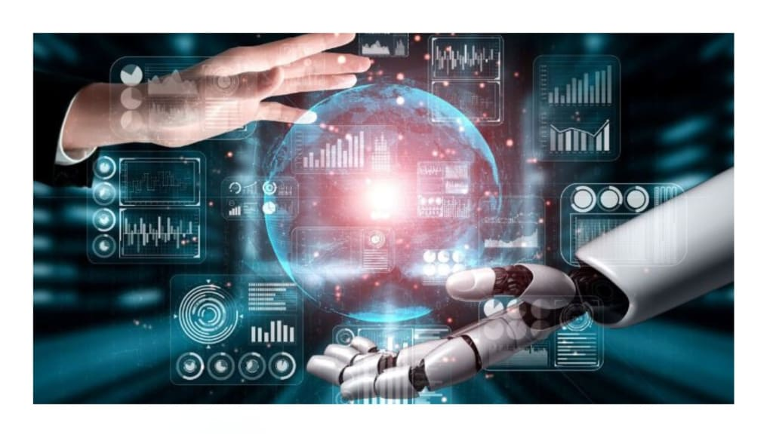

THANK YOU